DSP Education Kit
LAB 1: INSTRUCTOR VERSION
Analog Input and Output
Issue 1.0

Contents
1 Introduction 1
1.1 Lab Overview 1
2 Requirements 1
2.1.1 STM32F746G Discovery Board 1
3 Basic Digital Signal Processing System 2
4 Basic Analog Input and Output Using the STM32F746G Discovery Board 3
4.1 Program Operation of stm32f7_loop_intr.c 4
4.2 Running the Program 5
4.3 Use of GPIO Pin for Timing Indication 8
4.3.1 Connect an Oscilloscope Probe to Pin D13 on Connector CN7 to Confirm Timing 8
5 Delaying the Signal 8
6 Creating a Fading Echo Effect 10
6.1.1 Exercise 12
7 Real-Time Sine Wave Generation 13
7.1 Program Operation 13
7.2 Exercise: Modifying the Sine Wave 17
7.3 Viewing Program Output Using MATLAB 17
8 DMA-Based Example Program 20
9 Conclusions 24
10 Additional References 24

Introduction

Lab Overview
The STM32F746G Discovery board is a low-cost development platform featuring a 212 MHz Arm Cortex-M7 floating-point processor. It connects to a host PC via a USB A to Mini-B cable and uses the ST-LINK/V2 in-circuit programming and debugging tool. The Keil MDK-Arm development environment, running on the host PC, enables software written in C to be compiled, linked, and downloaded to run on the STM32F746G Discovery board. Real-time audio I/O is provided by a Wolfson WM8994 codec included on the board.
This laboratory exercise introduces the use of the STM32F746G Discovery board and several of the procedures and techniques that will be used in subsequent laboratory exercises.
Instructor note: Text in red and images in red boxes are for instructors only.

Requirements
To carry out this lab, you will need:
- An STM32F746G Discovery board
- A PC running Keil MDK-Arm
- MATLAB
- An oscilloscope
- Suitable connecting cables
- An audio frequency signal generator
- Optional: External microphone (although you can also use the microphones on the board)

STM32F746G Discovery Board
An overview of the STM32F746G Discovery board can be found in the Getting Started Guide.

Basic Digital Signal Processing System
A basic DSP system that is suitable for processing audio frequency signals comprises a digital signal processor and analog interfaces as shown in Figure 1. The STM32F746G Discovery board provides such a system, using a Cortex-M7 floating-point processor and a WM8994 codec.
The term codec refers to the coding of analog waveforms as digital signals and the decoding of digital signals as analog waveforms. The WM8994 codec performs both the Analog-to-Digital Conversion (ADC) and Digital-to-Analog Conversion (DAC) functions shown in Figure 1.
Figure 1: Basic digital signal processing system
Program code may be developed, downloaded, and run on the STM32F746G Discovery board using the Keil MDK-Arm integrated development environment (IDE). You will not be required to write C programs from scratch, but you will learn how to compile, link, download, and run the example programs provided, and in some cases, make minor modifications to their source files.
To do this, you will learn how to use a subset of the features provided by MDK-Arm (note that using the full capabilities of MDK-Arm is beyond the scope of this set of laboratory exercises). The emphasis of this set of laboratory exercises is on the digital signal processing concepts implemented by the programs.
Most of the example programs are quite short, and this is typical of real-time DSP applications. Compared with applications written for general purpose microprocessor systems, DSP applications are more concerned with the efficient implementation of relatively simple algorithms. In this context, efficiency refers to speed of execution and the use of resources such as memory.
The examples in this document introduce some of the features of MDK-Arm and the STM32F746G Discovery board. In addition, you will learn how to use MATLAB to analyze audio signals.

Basic Analog Input and Output Using the STM32F746G Discovery Board
The code snippet below shows a source file for a program that simply copies input samples read from two digital microphones mounted on the board and connected to the WM8994 codec and the WM8994 DAC. In effect, the program connects the digital microphones to the headphone output socket on the board. This simple program is important because many of the other example programs that will be used in subsequent laboratory exercises use the same interrupt-based, real-time structure. It is worth taking time to ensure that you understand how program stm32f7_loop_intr.c works, which will also be explained in this document.
In addition, this example introduces the MDK-Arm development environment and the editing, compiling, linking, and downloading procedures that you will use again for subsequent examples.

// stm32f7_loop_intr.c

#include "stm32f7_wm8994_init.h"
#include "stm32f7_display.h"

#define SOURCE_FILE_NAME "stm32f7_loop_intr.c"

extern int16_t rx_sample_L;
extern int16_t rx_sample_R;
extern int16_t tx_sample_L;
extern int16_t tx_sample_R;

void BSP_AUDIO_SAI_Interrupt_CallBack()
{
// when we arrive at this interrupt service routine
// the most recent input sample values are (already) in global
// variables rx_sample_L and rx_sample_R
// this routine should write new output sample values in
// global variables tx_sample_L and tx_sample_R

tx_sample_L = rx_sample_L;
tx_sample_R = rx_sample_R;
BSP_LED_Toggle(LED1);
return;
}

int main(void)
{
stm32f7_wm8994_init(AUDIO_FREQUENCY_48K,
IO_METHOD_INTR,
INPUT_DEVICE_DIGITAL_MICROPHONE_2,
OUTPUT_DEVICE_HEADPHONE,
WM8994_HP_OUT_ANALOG_GAIN_6DB,
WM8994_LINE_IN_GAIN_0DB,
WM8994_DMIC_GAIN_17DB,
SOURCE_FILE_NAME,
NOGRAPH);
while(1) {}
}

Program Operation of stm32f7_loop_intr.c
The operation of program stm32f7_loop_intr.c is as follows.
In function main(), an initialization function stm32f7_wm8994_init() is called. This configures the STM32F746G processor and WM8994 codec such that the codec will read (left and right channel) sample values from the digital microphones and interrupt the processor at a sampling frequency determined by the parameter AUDIO_FREQUENCY_48K passed to the function.
Parameter INPUT_DEVICE_DIGITAL_MICROPHONE_2 specifies that input to the WM8994 will come from the digital microphones on the STM32F746G Discovery board.
Parameter IO_METHOD_INTR passed to function stm32f7_wm8994_init()determines that interrupt, as opposed to DMA-based I/O, will be used by the program.
Parameter OUTPUT_DEVICE_HEADPHONE is redundant insofar as the headphone socket (CN10) is the only audio output currently supported in this DSP Education Kit.
Parameters WM8994_HP_OUT_ANALOG_GAIN_6DB, WM8994_LINE IN_GAIN_0DB, and WM8994_DMIC_GAIN_17DB concern the configuration of programmable gain blocks in the signal path through the codec.
Parameters SOURCE_FILE_NAME and NOGRAPH influence what will be shown on the Discovery board’s LCD.
There is no need to understand every detail of the initialization carried out by function stm32f7_wm8994_init(). After it has been called, interrupts generated by the Serial Audio Interface (SAI) peripheral in the STM32F746G microcontroller (to which the WM8994 codec is connected) will be enabled, and each time an interrupt occurs, the interrupt service routine function BSP_AUDIO_SAI_Interrupt_CallBack()will be called. One interrupt will occur per sampling period, and both left and right channel samples are processed in one call to function BSP_AUDIO_SAI_Interrupt_CallBack().
Following initialization, function main()enters an endless while() loop, doing nothing but waiting for interrupts.
When function BSP_AUDIO_SAI_Interrupt_CallBack() is called, new input sample values (from the WM8994 codec¹) may be read as variables rx_sample_L and rx_sample_R, and sample values written to variables tx_sample_L and tx_sample_R will be written to the WM8994 DAC at the next sampling instant.
¹Input sample values may have come either from the analog LINE IN socket (CN11) on the Discovery board, via the WM8994 ADC, or from the two digital microphones on the Discovery board, via a digital interface on the WM8994.

Running the Program
The following steps assume that you have followed all the steps described in the Getting Started Guide provided with the labs.
To run the stm32f7_loop_intr.c program, follow these steps:
- Open µVision 5 project DSP_Education_Kit by double-clicking on its icon, similar to the one used in the Getting Started Guide.
- Right-click on the STM32F746_DISCOVERY folder in the Project pane and select Manage Project Items, after which you should get a window like the one shown in Figure 2 below:

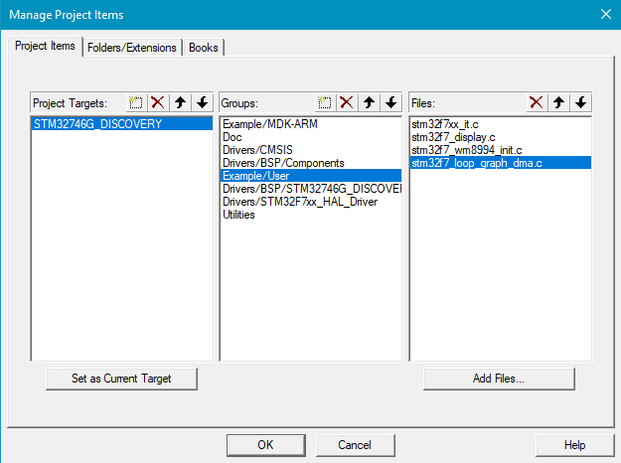
Figure 2: Screenshot of Manage Project Items

- Delete stm32f7_sine_lut_intr.c using the delete icon on the top right of the Files pane and then click on Add Files.
- Find stm32f7_loop_intr.c in the DSP Education Kit\Src folder and add it to the project. Click OK. You should now see a project structure like that shown in the Figure 3.

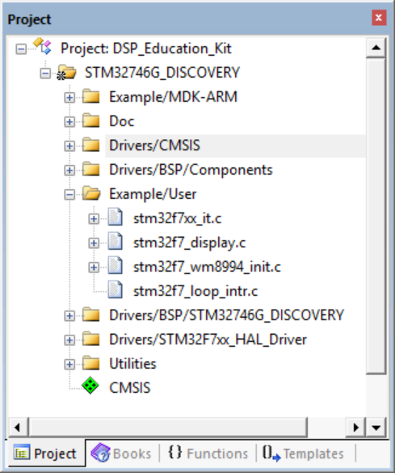
Figure 3: Screenshot of MDK-Arm showing the DSP_Education_Kit project

Note: Files stm32f7_loop_intr.c, stm32f7_wm8994_init.c, stm32f7xx_it.c, and stm32f7_display.c are supplied as part of the DSP Education Kit. Other files making up the project shown in Figure 3 are part of the STM32F746 Discovery board DFP Software Pack.
- Connect the STM32F746 Discovery board to the host PC using a USB A to Mini-B cable.
- Plug the headphones into the headset jack socket (CN10) on the board.
- Build the project by selecting the Project > Build target or by clicking on the Build toolbar button .
- After successfully building the project with no errors, switch to the debugger mode (and download the executable code into flash memory) by clicking on the Start/Stop Debug Session toolbar button .
- Once the Debugger View has appeared, click on the Run toolbar button .
- Once the program is running, you should see a start screen on the LCD on the board as shown in Figure 4. You should be able to hear sounds picked up by the digital microphones on the STM32F746 Discovery board (micro right and micro left on the right side of the LCD screen as shown in Figure 4). Depending on the characteristics of the headphones you are using, the sound may be loud or quiet. If you cannot hear anything, try blowing gently onto the microphones.

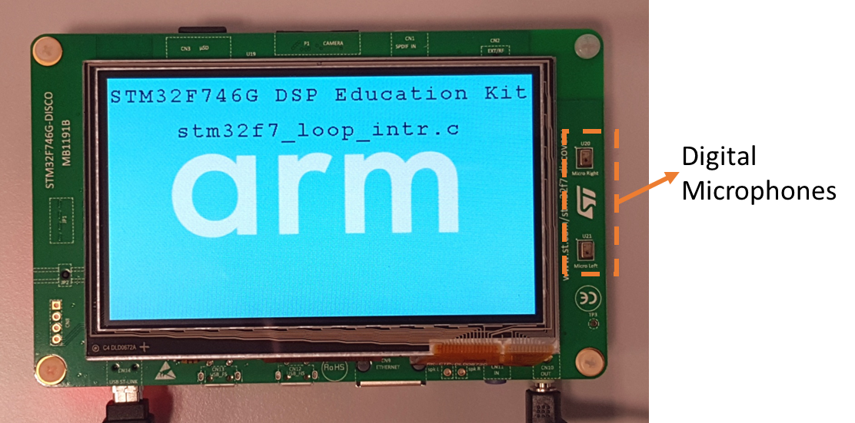
Figure 4: Start screen for program stm32f7_loop_intr.c

Optional: If you would like to use an external microphone instead of the microphones on the board, you can pass the parameter INPUT_DEVICE_INPUT_LINE_1 instead of INPUT_DEVICE_DIGITAL_MICROPHONE_2) to function stm32f7_wm8994_init(). You can listen to a signal input either via the LINE IN (CN11) socket on the board or via the digital microphones on the Discovery board. You can do this by editing the source file stm32f7_loop_intr.c, re-building the project, downloading, and running the program.

Use of GPIO Pin for Timing Indication
In several example programs, including stm32f7_loop_intr.c, the state (HIGH or LOW) of a GPIO pin is used so that we can obtain an indication of the execution of a program by connecting an oscilloscope to that pin.
In the case of program stm32f7_loop_intr.c, GPIO pin PI1 is toggled each time an interrupt occurs, i.e., in the interrupt service routine BSP_AUDIO_SAI_Interrupt_CallBack(), using program statement BSP_LED_Toggle(LED1).
GPIO pin PI1 is accessible via pin D13 on connector CN7 and drives the green LED (LD1) next to the black reset pushbutton (B2).
Since interrupts should occur once per sampling period, the expected signal on GPIO pin PI1 is a square wave of frequency 24 kHz (if the sampling rate is 48 kHz).

Connect an Oscilloscope Probe to Pin D13 on Connector CN7 to Confirm Timing
GPIO pin PI1 may be set (HIGH) or reset (LOW) using program statements
BSP_LED_On(LED1);
BSP_LED_Off(LED1);

Alternatively, GPIO pin PI2, accessible via pin D8 on connector CN7 but not connected to an LED, may be set (HIGH), reset (LOW), or toggled using program statements:

BSP_GPIO_On();
BSP_GPIO_Off();
BSP_GPIO_Toggle();

Delaying the Signal
Some simple, yet striking, effects can be achieved by delaying the samples as they pass from input to output. Program stm32f7_delay_intr.c demonstrates this.
A delay line is implemented using the array buffer to store samples as they are read from the digital microphones. Once the array is full, the pointer bufptr is reset and the program overwrites the oldest stored input sample with the newest input sample. Just prior to overwriting the oldest stored input sample in buffer, that sample is retrieved, added to the current input, and written to the WM8994 DAC. The length of the delay is determined by the value of the constant DELAY_BUF_SIZE. As supplied, this is equal to 24000 samples, corresponding to a delay of 500 ms at a sampling rate of 48 kHz.
The following code snippet shows the source code of stm32f7_delay_intr.c.
#include "stm32f7_wm8994_init.h"
#include "stm32f7_display.h"

#define SOURCE_FILE_NAME "stm32f7_delay_intr.c"
#define DELAY_BUF_SIZE 24000

extern int16_t rx_sample_L;
extern int16_t rx_sample_R;
extern int16_t tx_sample_L;
extern int16_t tx_sample_R;

int16_t buffer[DELAY_BUF_SIZE];
int16_t bufptr = 0;

void BSP_AUDIO_SAI_Interrupt_CallBack()
{
// when we arrive at this interrupt service routine (callback)
// the most recent input sample values are (already) in global variables
// rx_sample_L and rx_sample_R
// this routine should write new output sample values in
// global variables tx_sample_L and tx_sample_R
int16_t delayed_sample;

delayed_sample = buffer[bufptr];
tx_sample_L = delayed_sample + rx_sample_L;
buffer[bufptr] = rx_sample_L;
bufptr = (bufptr+1) % DELAY_BUF_SIZE;
tx_sample_R = tx_sample_L;

BSP_LED_Toggle(LED1);

return;
}

int main(void)
{
stm32f7_wm8994_init(AUDIO_FREQUENCY_48K,
IO_METHOD_INTR,
INPUT_DEVICE_DIGITAL_MICROPHONE_2,
OUTPUT_DEVICE_HEADPHONE,
WM8994_HP_OUT_ANALOG_GAIN_6DB,
WM8994_LINE_IN_GAIN_0DB,
WM8994_DMIC_GAIN_17DB,
SOURCE_FILE_NAME,
NOGRAPH);
while(1){}
}

Figure 5: Block diagram representation of program stm32f7_delay_intr.c

Creating a Fading Echo Effect
By feeding back a fraction of the output of the delay line to its input, a fading echo effect can be realized. The program stm32f7_echo_intr.c, shown in the following code snippet, does this.
// stm32f7_echo_intr.c

#include "stm32f7_wm8994_init.h"
#include "stm32f7_display.h"

#define SOURCE_FILE_NAME "stm32f7_echo_intr.c"
#define DELAY_BUF_SIZE 6000
#define GAIN 0.6f

extern int16_t rx_sample_L;
extern int16_t rx_sample_R;
extern int16_t tx_sample_L;
extern int16_t tx_sample_R;

int16_t buffer[DELAY_BUF_SIZE];
int16_t bufptr = 0;

void BSP_AUDIO_SAI_Interrupt_CallBack()
{
// when we arrive at this interrupt service routine (callback)
// the most recent input sample values are (already) in global variables
// rx_sample_L and rx_sample_R
// this routine should write new output sample values in
// global variables tx_sample_L and tx_sample_R
int16_t delayed_sample;

delayed_sample = buffer[bufptr];
tx_sample_L = delayed_sample + rx_sample_L;
buffer[bufptr] = rx_sample_L + delayed_sample*GAIN;
bufptr = (bufptr+1) % DELAY_BUF_SIZE;
tx_sample_R = 0;

BSP_LED_Toggle(LED1);

return;
}

int main(void)
{
stm32f7_wm8994_init(AUDIO_FREQUENCY_48K,
IO_METHOD_INTR,
INPUT_DEVICE_DIGITAL_MICROPHONE_2,
OUTPUT_DEVICE_HEADPHONE,
WM8994_HP_OUT_ANALOG_GAIN_6DB,
WM8994_LINE_IN_GAIN_0DB,
WM8994_DMIC_GAIN_17DB,
SOURCE_FILE_NAME,
NOGRAPH);
while(1){}
}

Exercise
Experiment with different values of the constants DELAY_BUF_SIZE and GAIN. The delay in seconds is equal to DELAY_BUF_SIZE divided by the sampling frequency in Hz, and the fraction of the delayed signal fed back is equal to GAIN.
- What would happen if the value of GAIN were made greater than or equal to 1?
If GAIN=1, then the echo will not fade, it remains the same (repeated). If GAIN>1, then it gets louder at each echo.
- Study the program listing in stm32f7_echo_intr.c and, with reference to Figure 5, draw a block diagram of the system it implements in the space provided below. In the space below that, sketch what you think its response to a unit impulse at time t = 0 would be (with a GAIN of 0.6 and a DELAY_BUF_SIZE size of 2000 samples).
Block diagram representation of program stm32f7_echo_intr.c:

Impulse response of program stm32f7_echo_intr.c (DELAY_BUF_SIZE = 2000, GAIN = 0.6):

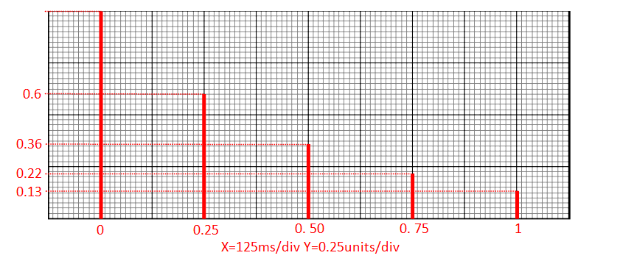

Real-Time Sine Wave Generation

Program Operation
The C source file stm32f7_sine_lut_intr.c, shown in the code snippet below, generates a sinusoidal signal using interrupts and a table lookup method.
// stm32f7_sine_lut_intr.c

#include "stm32f7_wm8994_init.h"
#include "stm32f7_display.h"

#define SOURCE_FILE_NAME "stm32f7_sine_lut_intr.c"
#define LOOPLENGTH 8

extern int16_t rx_sample_L;
extern int16_t rx_sample_R;
extern int16_t tx_sample_L;
extern int16_t tx_sample_R;

int16_t sine_table[LOOPLENGTH] = {0, 7071, 10000, 7071, 0, -7071, -10000, -7071};
int16_t sine_ptr = 0; // pointer into lookup table

void BSP_AUDIO_SAI_Interrupt_CallBack()
{
// when we arrive at this interrupt service routine (callback)
// the most recent input sample values are (already) in global variables
// rx_sample_L and rx_sample_R
// this routine should write new output sample values in
// global variables tx_sample_L and tx_sample_R

BSP_LED_On(LED1);
tx_sample_L = sine_table[sine_ptr];
sine_ptr = (sine_ptr+1)%LOOPLENGTH;
tx_sample_R = tx_sample_L;
BSP_LED_Off(LED1);

return;
}

int main(void)
{
stm32f7_wm8994_init(AUDIO_FREQUENCY_8K,
IO_METHOD_INTR,
INPUT_DEVICE_INPUT_LINE_1,
OUTPUT_DEVICE_HEADPHONE,
WM8994_HP_OUT_ANALOG_GAIN_0DB,
WM8994_LINE_IN_GAIN_0DB,
WM8994_DMIC_GAIN_9DB,
SOURCE_FILE_NAME,
GRAPH);
plotSamples(sine_table, LOOPLENGTH, 32);
while(1){}
}

An eight-point lookup table is initialized using the array sine_table such that the value of sine_table[i] is equal to
$$\text{sine_table}[i]=10000\sin{(}(2πi/8)+φ)$$
where in this case, . The LOOPLENGTH values in array sine_table are samples of exactly one cycle of a sinusoid.
Just as in the previous examples, in function main(), the initialization function stm32f7_wm8994_init() is called. This configures processor and codec such that the WM8994 will sample, and interrupt the processor, at a frequency determined by the parameter value AUDIO_FREQUENCY_8K, i.e., in this case at 8 kHz. Interrupts will occur every 0.125 ms.
Following the call to function stm32f7_wm8994_init(), function main() enters an endless loop, doing nothing but waiting for interrupts (which will occur once per sampling period).
Upon an interrupt occurring, the interrupt service routine function BSP_AUDIO_SAI_Interrupt_CallBack() is called, and in that routine, the most important program statements are executed: the sample values read from array sine_table are written to both channels to the DAC and the index variable sine_ptr is incremented to point to the next value in the array.
The 1 kHz frequency of the sinusoidal output signal corresponds to the eight samples per cycle output at a rate of 8 kHz.
The WM8994 DAC is effectively a low pass reconstruction filter that interpolates between output sample values to give a continuous sinusoidal analog output signal as shown in Figure 6. This will be explained further in the next lab exercise.

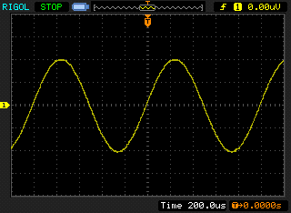
Figure 6: Analog output generated by program stm32f7_sine_lut_intr.c

When you run the program, you should see a start screen on the LCD as shown in Figure 7. Press the blue user pushbutton to continue, and you should see a graphical representation of the sequence of discrete sample values being written to the DAC (Figure 8). The sample values are represented as bars in the graph on the LCD to emphasize that it is the discrete sample values written to the DAC that are being shown and not the continuous-time signal output by the DAC. Connect one channel of the audio card HEADPHONE OUT output to an oscilloscope and verify that the output signal is a 1 kHz sinusoid using both time-domain and frequency-domain oscilloscope displays.

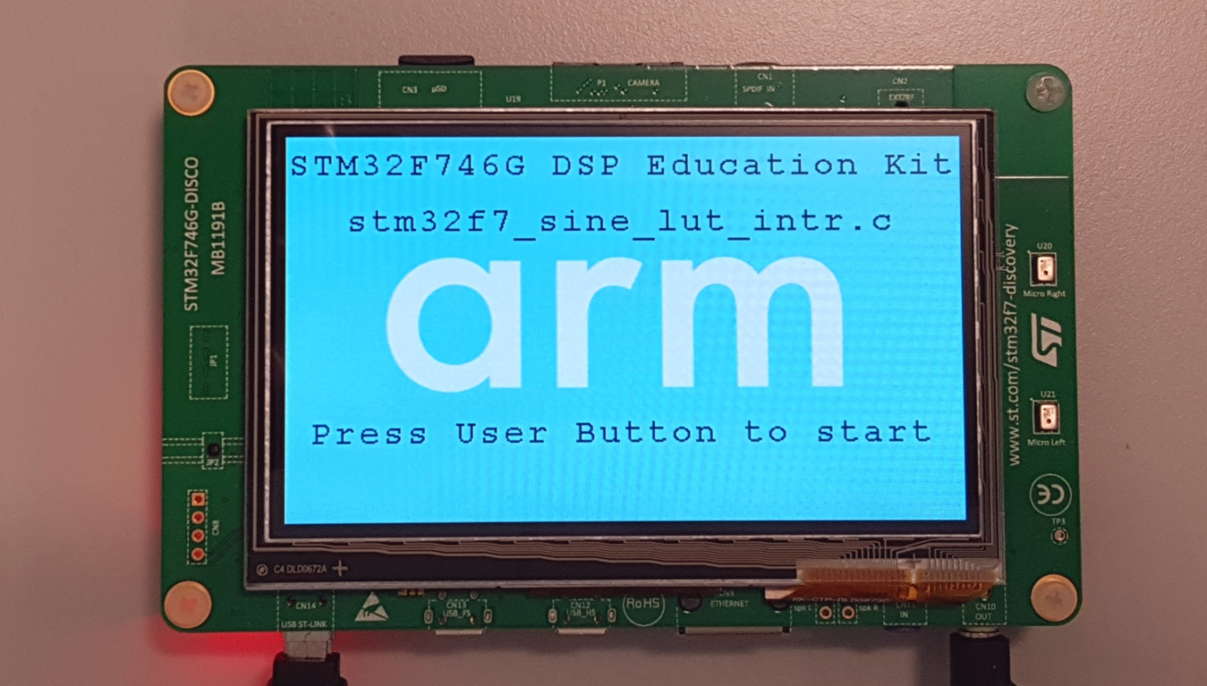
Figure 7: Start screen for program stm32f7_sine_lut_intr.c

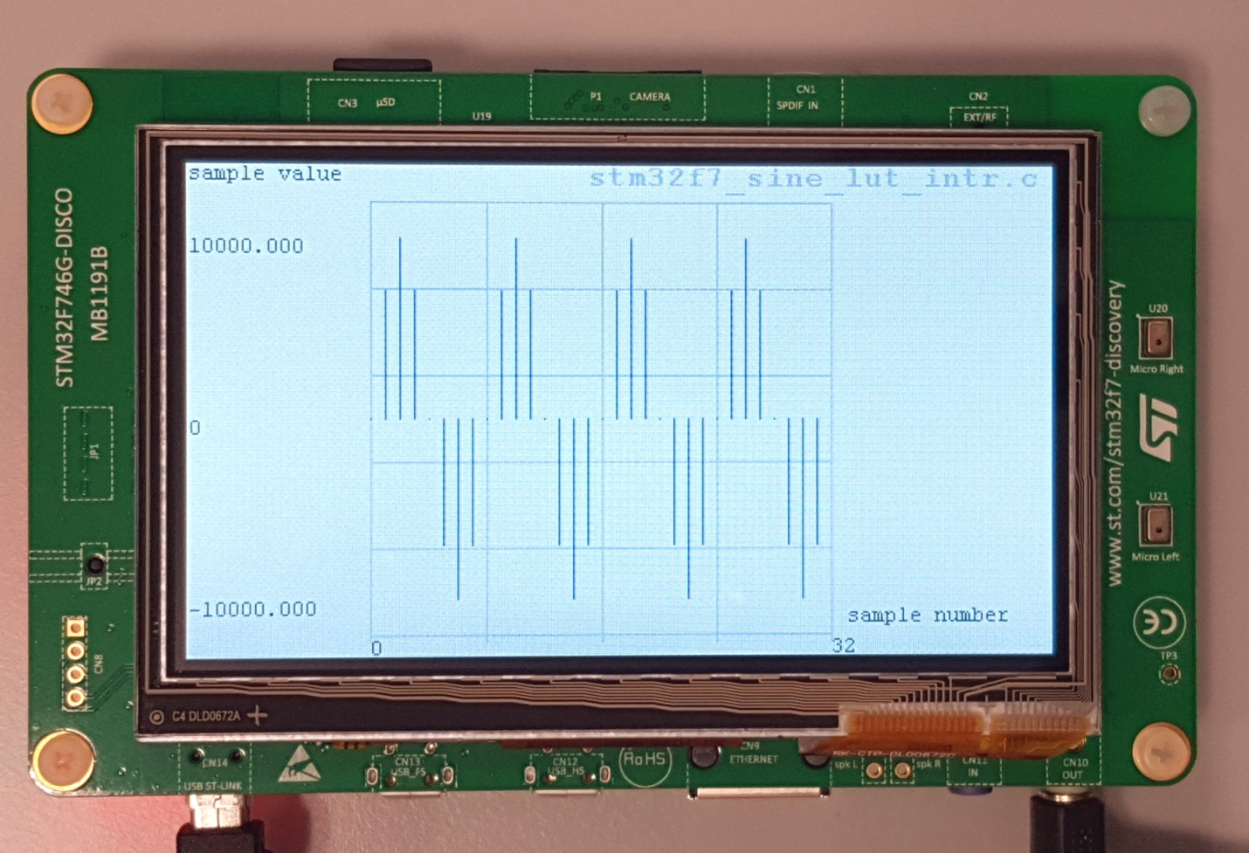
Figure 8: Graphical representation of first 32 sample values output by program stm32f7_sine_lut_intr.c

Exercise: Modifying the Sine Wave
Edit the source file stm32f7_sine_lut_intr.c to generate
1. A 500 Hz sinusoid
2. A 2000 Hz sinusoid
3. A 3000 Hz sinusoid
You should be able to achieve these simply by changing the initialized contents of the array sine_table (and by changing the value of the constant LOOPLENGTH accordingly). Do not change any other program statements. Record the combinations of LOOPLENGTH and sine_table with which you achieve these results in the space below.

500 Hz sinewave
LOOPLENGTH = 16
sine_table = {0, 3827, 7071, 9239, 10000, 9239, 7071, 3827, 0, -3827, -7071, -9239, -10000, -9239, -7071, -3827}

2000 Hz sinewave
LOOPLENGTH = 4
sine_table = {0, 10000, 0, -10000}
There are an infinite number of different correct solutions to this and to the other two problems set here, corresponding to different values of phi. For example, in this case, another (slightly less intuitive) solution is:
{7071, 7071, -7071, -7071}

3000 Hz sinewave
LOOPLENGTH = 8
sine_table = {0, 7071, -10000, 7071, 0, -7071, 10000, -7071}

Viewing Program Output Using MATLAB
To view your program output in MATLAB, you can first store the output values into a file and then use MATLAB to load the values from the saved file.
stm32f7_sine_lut_buf.c shows how to store the output values. It is very similar to the program stm32f7_sine_lut_intr.c, but it also stores the most recent BUFFER_LENGTH number of output values in the array buffer. The array buffer is of type float32_t for compatibility with the MATLAB function that will be used to view its contents.
To save the program output into a file and view them in MATLAB, follow these steps:
- Run the program and press the user button to start the program.
- Halt it by clicking on the Stop toolbar button in the MDK_Arm debugger.
- Type the variable name buffer as the Address in the debugger’s Memory 1 window. Right-click on the Memory 1 window and set the displayed data type to Decimal and Float as shown in Figure 9.
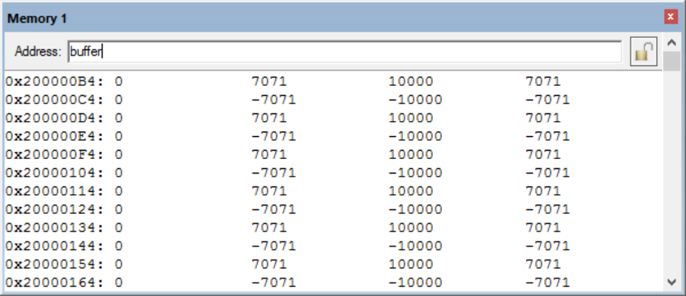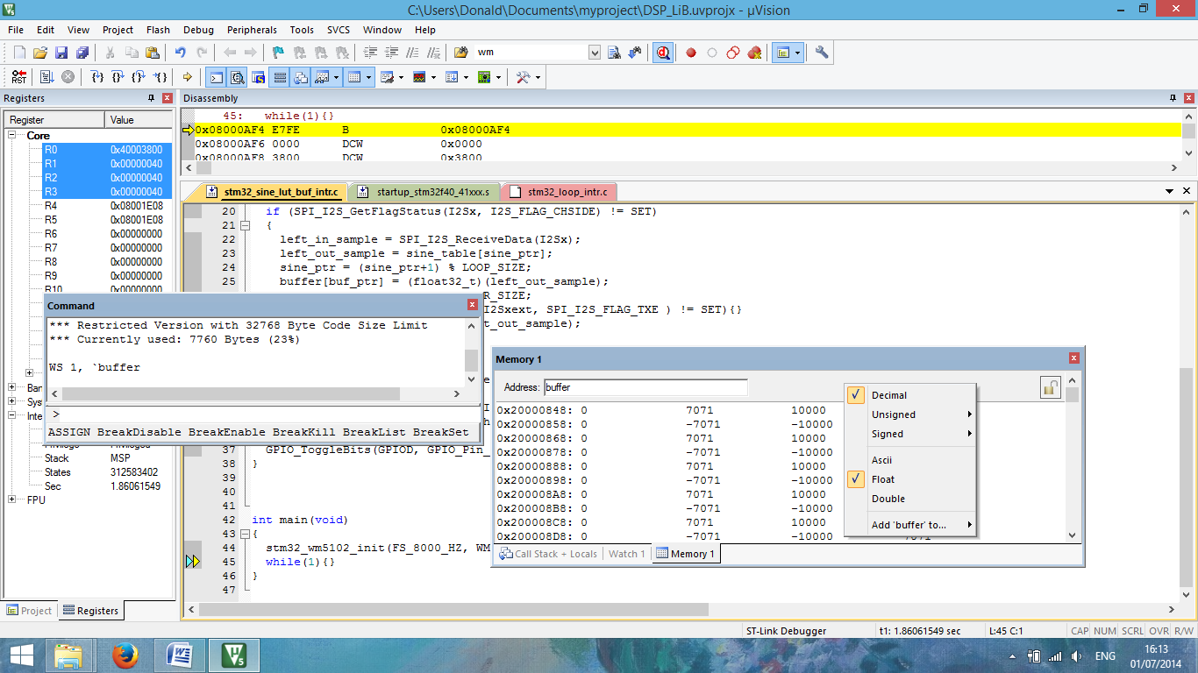
Figure 9: Memory 1 window showing the contents of array buffer

The start address of array buffer will be displayed in the top left-hand corner of the window.
- Use the following command at the prompt in the debugger’s Command window to save the contents of array buffer to a file in your project folder.
SAVE <filename> <start address>, <end address>
The end address should be the start address plus 0×190 (bytes) representing 100 32-bit sample values. For example,
SAVE sinusoid.dat 0×200000B4, 0×20000244
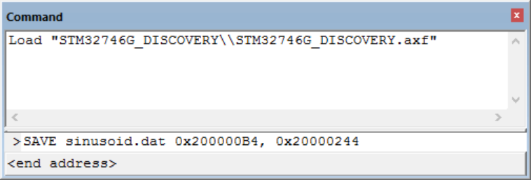
Figure 10: Saving data to file in MDK-Arm

- Launch MATLAB and run the MATLAB function stm32f7_logfft.m (provided with the DSP Education Kit in General_Matlab_Files\) to obtain a graphical representation of the contents of the buffer. The MATLAB function will require you to input some information, such as the saved .dat filename (full path) and sampling frequency.
There are some subtleties here, linked to the simplicity of function stm32f7_logfft(). It is designed to read 32-bit floating point values from a file saved in MDK-Arm. Rather than modify the MATLAB function, which is used again in other lab exercises, it is easier to convert the 16-bit integer sample values written to the DAC to 32-bit floating point values in program stm32f7_sine_lut_buf_intr.c. The size of the buffer used to store output sample values has deliberately been chosen so that the buffer will not hold an integer number of cycles of the 1 kHz sinusoid being generated. This leads to spectral leakage in the frequency domain representation of the data plotted in MATLAB. The important feature of the magnitude frequency response plot is the 1 kHz center frequency of the single peak rather than its shape. If BUFFER_LENGTH is adjusted to be equal to an integer multiple of LOOPLENGTH, then function stm32f7_logfft() will run into problems computing the logs of zero values in the FFT. In general, zero FFT values will not be encountered by function stm32f7_logfft().
MATLAB resulting plot using stm32f7_logfft.m:
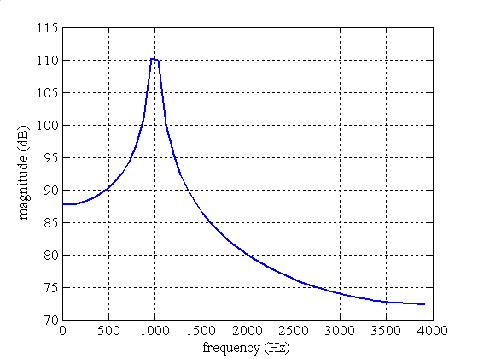

DMA-Based Example Program
Direct Memory Access (DMA) is a method in which a hardware component of a computer gains access to the Memory Bus and controls the transfer. DMA controllers can be configured to handle data transfers between memories, memory to peripherals, and vice versa, allowing the processor to deal with other processes. Essentially, the main benefit of this method is to reduce strain on the CPU. This concept is demonstrated in the block diagram below:

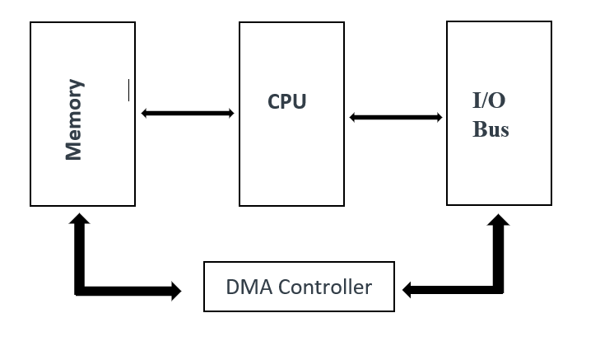
Figure 11: Block diagram representation DMA-Based I/O

Program stm32f7_loop_graph_dma.c. has similar functionality to program stm32f7_loop_intr.c except that it uses the DMA I/O, as opposed to using an interrupt-based method. DMA-based I/O is investigated in more detail in Lab 5.
Run program stm32f7_loop_graph_dma.c and confirm that input to the digital microphones is passed to the headphones. A major difference between programs stm32f7_loop_intr.c and stm32f7_loop_graph_dma.c is that the latter program plots the sample values it writes to the WM8994 DAC as a graph on the LCD. Pressing the blue user pushbutton toggles between time-domain and frequency-domain representations of those sample values.
// stm32f7_loop_graph_dma.c

#include "stm32f7_wm8994_init.h"
#include "stm32f7_display.h"

#define PLOTBUFSIZE 128

#define BLOCK_SIZE 1

#define SOURCE_FILE_NAME "stm32f7_loop_graph_dma.c"

extern volatile int32_t TX_buffer_empty; // these may not need to be int32_t
extern volatile int32_t RX_buffer_full; // they were extern volatile int16_t in F4 version
extern int16_t rx_buffer_proc, tx_buffer_proc; // will be assigned token values PING or PONG

float32_t x[PING_PONG_BUFFER_SIZE];

float32_t cmplx_buf[2*PING_PONG_BUFFER_SIZE];
float32_t outbuffer[PING_PONG_BUFFER_SIZE] = { 0.0f };

void process_buffer(void) // this function processes one DMA transfer block of data
{
int i;
int16_t *rx_buf, *tx_buf;

if (rx_buffer_proc == PING) {rx_buf = (int16_t *)PING_IN;}
else {rx_buf = (int16_t *)PONG_IN;}
if (tx_buffer_proc == PING) {tx_buf = (int16_t *)PING_OUT;}
else {tx_buf = (int16_t *)PONG_OUT;}

for (i=0 ; i<(PING_PONG_BUFFER_SIZE) ; i++)
{
x[i] = (float32_t)(*rx_buf);
*tx_buf++ = *rx_buf++;
*tx_buf++ = *rx_buf++;
cmplx_buf[i*2] = x[i]; // real part
cmplx_buf[(i*2)+1] = 0.0; // imaginary part
}

RX_buffer_full = 0;
TX_buffer_empty = 0;
}

int main(void)
{
int i;
int button = 0;

stm32f7_wm8994_init(AUDIO_FREQUENCY_8K,
IO_METHOD_DMA,
INPUT_DEVICE_DIGITAL_MICROPHONE_2,
OUTPUT_DEVICE_HEADPHONE,
WM8994_HP_OUT_ANALOG_GAIN_0DB,
WM8994_LINE_IN_GAIN_0DB,
WM8994_DMIC_GAIN_9DB,
SOURCE_FILE_NAME,
GRAPH);
while(1)
{
while(!(RX_buffer_full && TX_buffer_empty)){}
BSP_LED_On(LED1);
process_buffer();
button = checkButtonFlag();
if(button == 1)
{
for(i=0; i<PING_PONG_BUFFER_SIZE; i++)
{
cmplx_buf[2*i] = x[i];
cmplx_buf[2*i + 1] = 0.0;
}
arm_cfft_f32(&arm_cfft_sR_f32_len256, (float32_t *)(cmplx_buf), 0, 1);
arm_cmplx_mag_f32((float32_t *)(cmplx_buf),(float32_t *)(outbuffer), PING_PONG_BUFFER_SIZE);
plotLogFFT(outbuffer, PING_PONG_BUFFER_SIZE, LIVE);
}
else
{
plotWave(x, PLOTBUFSIZE, LIVE, ARRAY);
}
BSP_LED_Off(LED1);
}
}
Figure 12: Listing of program stm32f7_loop_graph_dma.c
The DMA-based I/O method introduces a delay in the signal path equal to two DMA transfer blocks, or buffers, of samples. The number of sampling periods represented by one DMA transfer block is determined by the value of PING_PONG_BUFFER_SIZE, defined in header file stm32f7_wm8994_init.h. If you change the sampling frequency in program stm32f7_loop_graph_dma.c from 48 kHz to 8 kHz, you may be able to discern a slight delay between the signal input to the digital microphones and the signal output to the headphones.
Change the parameter INPUT_DEVICE_DIGITAL_MICROPHONE_2 to INPUT_DEVICE_INPUT_LINE_1 and the sampling frequency back to 8 kHz in program stm32f7_loop_graph_dma.c and use a signal generator to input a sinusoid of frequency 250 Hz to the LINE IN input. You should see graphs on the LCD similar to those shown in Figures 13 and 14.
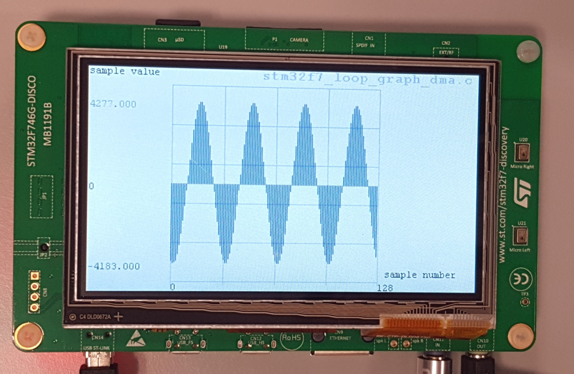
Figure 13: Graphical representation of 250 Hz sinusoidal signal input to program stm32f7_loop_graph_dma.c in the time-domain. Sampling frequency is 8 kHz
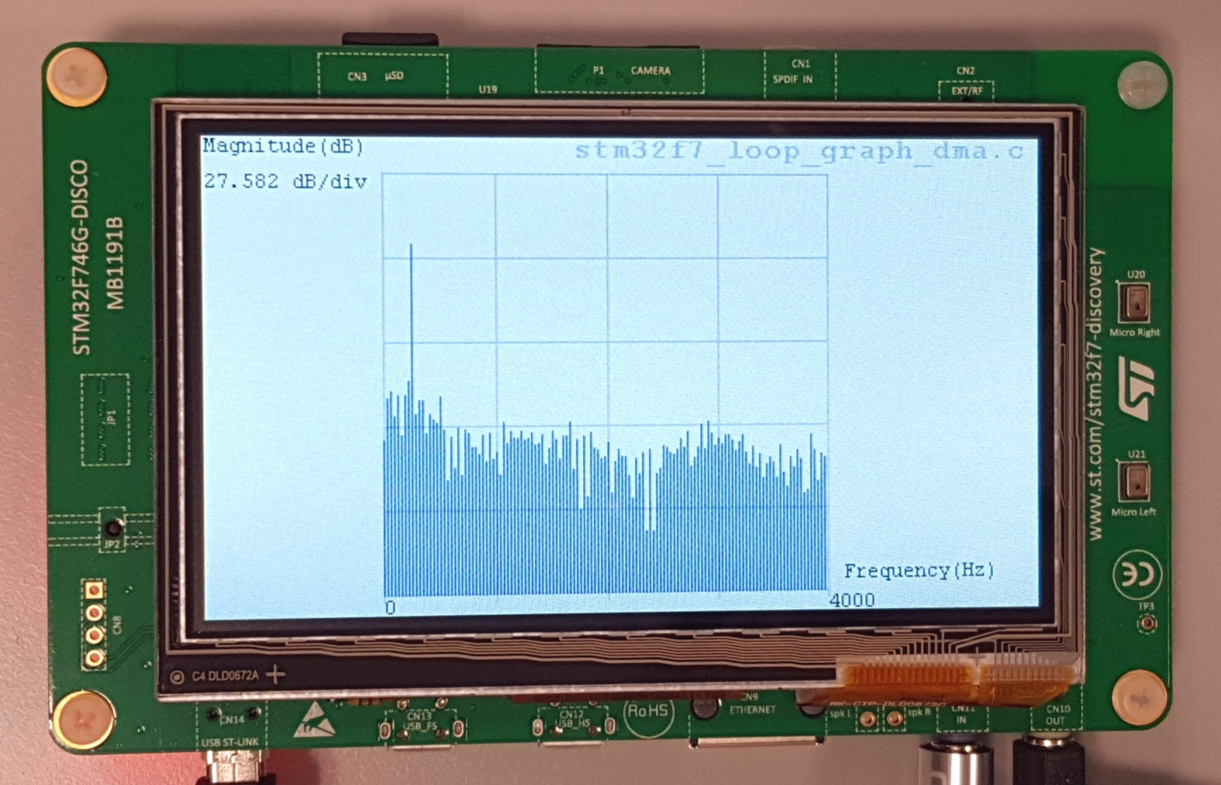
Figure 14: Graphical representation of 250 Hz sinusoidal signal input to program stm32f7_loop_graph_dma.c in the frequency-domain. Sampling frequency is 8 kHz

Conclusions
You should now be familiar with several of the tools and techniques that you will use in subsequent lab exercises.

Additional References
Link to Board information and resources:
https://www.st.com/en/evaluation-tools/32f746gdiscovery.html#overview
Using DMA controllers in STM Discovery boards:
https://www.st.com/content/ccc/resource/technical/document/application_note/27/46/7c/ea/2d/91/40/a9/DM00046011.pdf/files/DM00046011.pdf/jcr:content/translations/en.DM00046011.pdf
For more details about DMA:
http://cires1.colorado.edu/jimenez-group/QAMSResources/Docs/DMAFundamentals.pdf

